Warning signal for unauthorised person

Description:

Automation, security feature Unauthorised Door Open Detection - Securing doors against the unauthorized door opening in 2N® IP Intercom.

This automation will cause a sound to be played once the door is open without authorization.
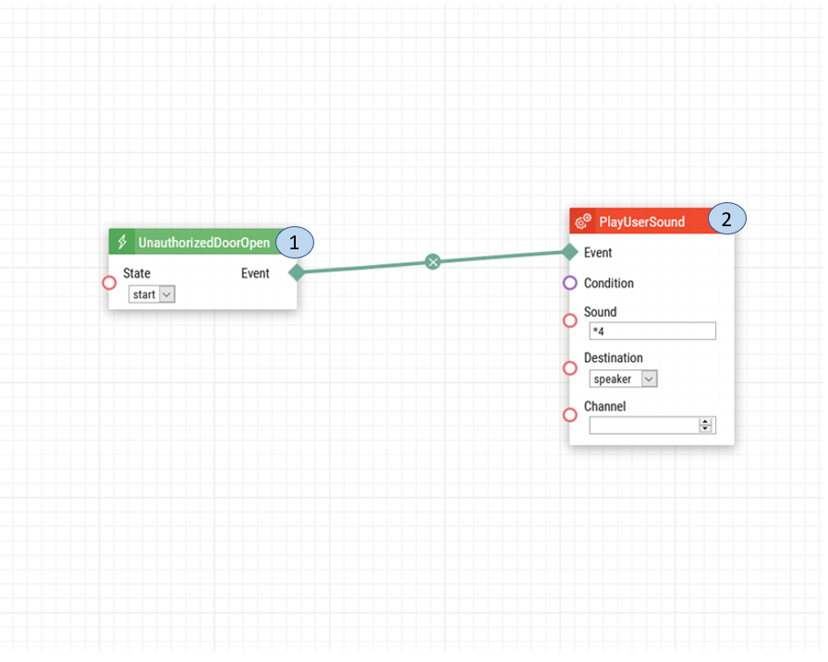

Intercom Door Configuration:
If you have previously configured the unauthorized door open setting please follow the steps below.

- Unauthorized Open Door. Once an unauthorized open door is detected, a signal is sent to play a user sound.
- Play User Sound. The sound played when the door is opened without authorization.

1: Upon login select the Hardware option.
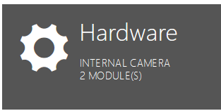
2: From the left-hand menu select Door.
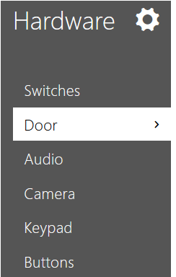

3: In the Door tab, enable the Unauthorized Door open Detection. As well, set the Door Sensor to the correct Input and then save the settings.
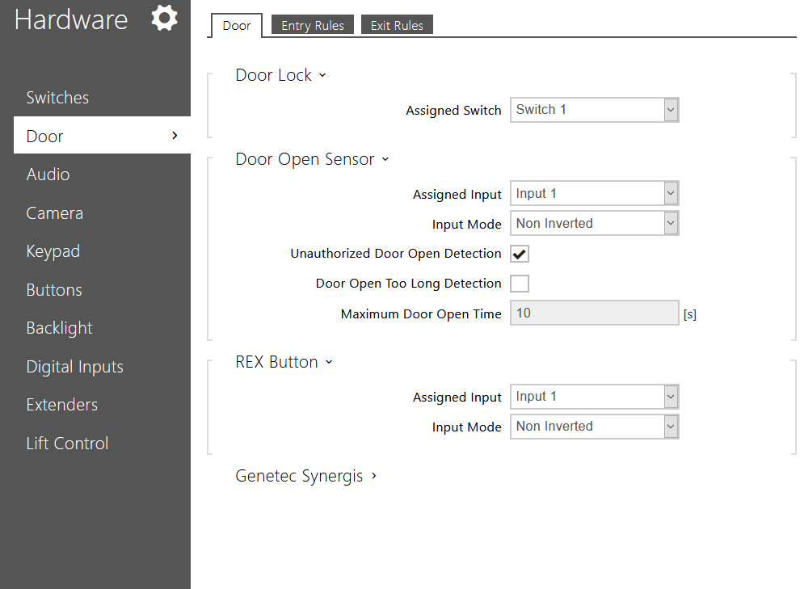
Date of automation design: 07/17/2020

Firmware Version: 2.29.1.38.8

List of compatible Hardware:
- 2N IP Verso
- 2N IP Vario
- 2N IP Force
- 2N IP Safety
- 2N IP Base
- 2N IP Solo
- 2N LTE Verso
List of automation parameters:
- Sound
- Destination
- Channel

Requirements:
- 2N Intercom
- 2N Enhanced Integration Licence (or Gold Licence) *Not applicable to the USA
- Door Sensor

